UNITED STATES
SECURITIES AND EXCHANGE COMMISSION
WASHINGTON, D.C. 20549
FORM 8-K
CURRENT REPORT
Pursuant to Section 13 or 15(d) of the Securities Exchange Act of 1934
Date of report (Date of earliest event reported): July 30, 2026
LSB INDUSTRIES, INC.
(Exact name of registrant as specified in its charter)
Delaware |  | 1-7677 |  | 73-1015226
(State or other jurisdiction  of incorporation) |  | (Commission  File Number) |  | (IRS Employer  Identification No.)
3503 NW 63rd Street, Suite 500, Oklahoma City, Oklahoma |  |  |  | 73116
(Address of principal executive offices) |  |  |  | (Zip Code)
Registrant’s telephone number, including area code (405) 235-4546
Not applicable
(Former name or former address, if changed since last report)
Check the appropriate box below if the Form 8-K filing is intended to simultaneously satisfy the filing obligation of the registrant under any of the following provisions (see General Instruction A.2. below):
☐ | Written communications pursuant to Rule 425 under the Securities Act (17 CFR 230.425)
☐ | Soliciting material pursuant to Rule 14a-12 under the Exchange Act (17 CFR 240.14a-12)
☐ | Pre-commencement communications pursuant to Rule 14d-2(b) under the Exchange Act (17 CFR 240.14d-2(b))
☐ | Pre-commencement communications pursuant to Rule 13e-4(c) under the Exchange Act (17 CFR 240.13e-4(c))
Securities registered pursuant to Section 12(b) of the Act:

Title of each class |  | Trading Symbol(s) |  | Name of each exchange on which registered
Common Stock, Par Value $.10 |  | LXU |  | New York Stock Exchange
Preferred Stock Purchase Rights |  | N/A |  | New York Stock Exchange

Indicate by check mark whether the registrant is an emerging growth company as defined in Rule 405 of the Securities Act of 1933 (§ 230.405 of this chapter) or Rule 12b-2 of the Securities Exchange Act of 1934 (§ 240.12b-2 of this chapter).
Emerging growth company ☐
If an emerging growth company, indicate by check mark if the registrant has elected not to use the extended transition period for complying with any new or revised financial accounting standards provided pursuant to Section 13(a) of the Exchange Act. ☐

Item 7.01 | Regulation FD Disclosure.
On July 30, 2026, LSB Industries, Inc. (the “Company”) made available on its website a financial presentation (the “Presentation”) regarding its financial results for the second quarter ended June 30, 2026. A copy of the Presentation is attached hereto as Exhibit 99.1. The Presentation is incorporated by reference into this Item 7.01, and the foregoing description of the Presentation is qualified in its entirety by reference to Exhibit 99.1.
The information contained in the Presentation is summary information that is intended to be considered in the context of the Company’s Securities and Exchange Commission filings and other public announcements that the Company may make, by press release or otherwise, from time to time. The Company undertakes no duty or obligation to publicly update or revise the information contained in the Presentation, although it may do so from time to time as its management believes is warranted.
The information contained in Item 7.01 of this Form 8-K and the Exhibit 99.1 attached hereto are being furnished and shall not be deemed “filed” for the purposes of Section 18 of the Securities Exchange Act of 1934, as amended (the “Exchange Act”), or otherwise subject to the liabilities of such section, nor shall it be deemed incorporated by reference in any filing under the Securities Act of 1933, as amended, or the Exchange Act, except as shall be expressly set forth by specific reference to this Item 7.01 in such filing.
Item 9.01 | Exhibits.
(d) Exhibits.
Exhibit  Number |  | Description
99.1 |  | Financial Presentation (furnished pursuant to Item 7.01).
104 |  | Cover Page Interactive Data File (embedded within the XBRL document)

2

SIGNATURES
Pursuant to the requirements of the Securities Exchange Act of 1934, the Company has duly caused this report to be signed on its behalf by the undersigned hereunto duly authorized.
Dated: July 30, 2026
LSB INDUSTRIES, INC.
By: |  | /s/ Cheryl A. Maguire
Name: |  | Cheryl A. Maguire
Title: |  | Executive Vice President and Chief Financial Officer (Principal Financial and Accounting Officer)

3

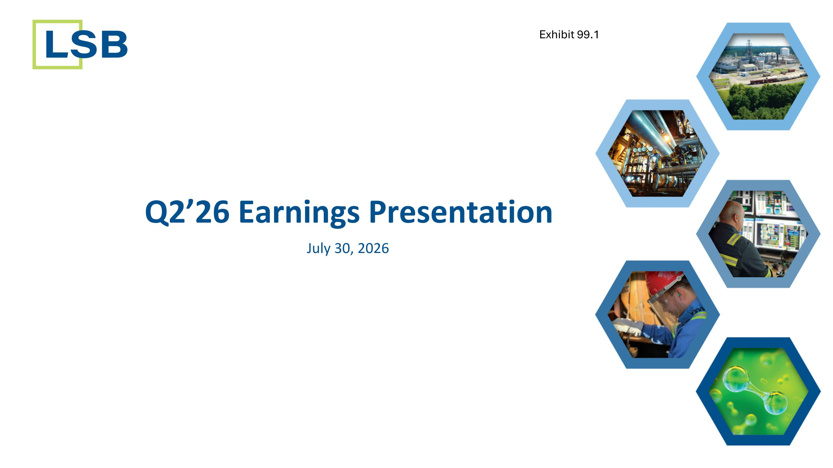
Q2’26 Earnings Presentation July 30, 2026 Exhibit 99.1

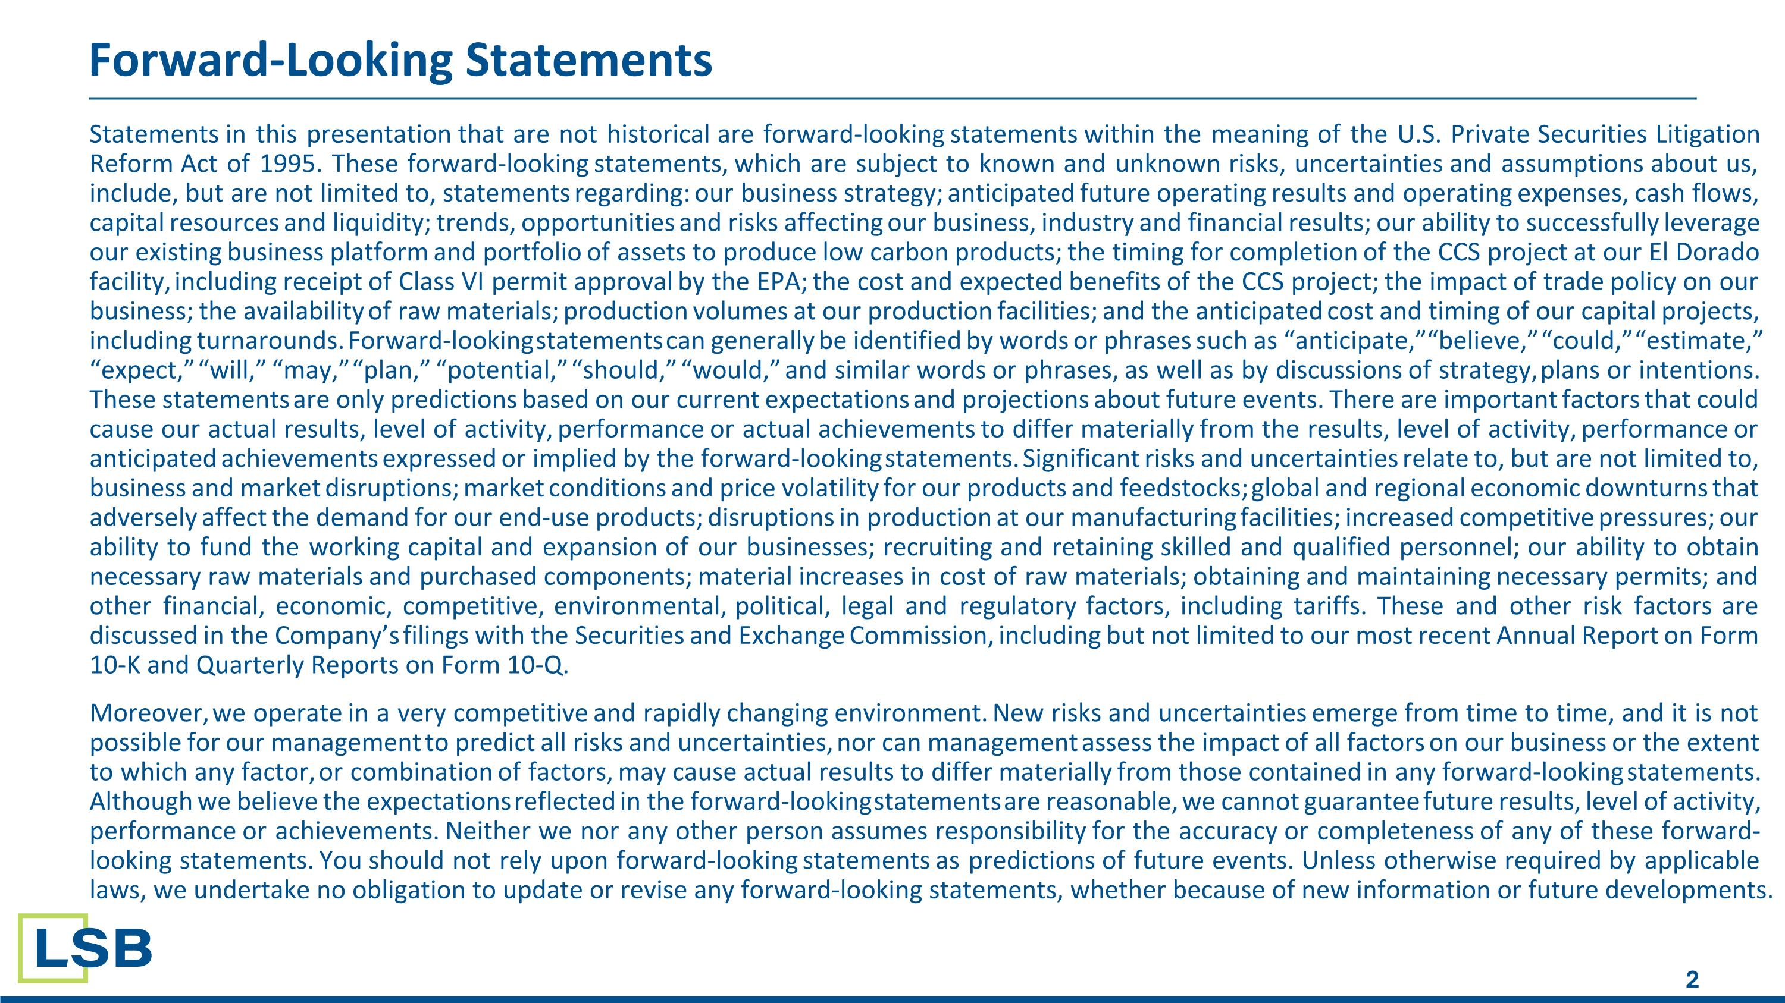
Statements in this presentation that are not historical are forward-looking statements within the meaning of the U.S. Private Securities Litigation Reform Act of 1995. These forward-looking statements, which are subject to known and unknown risks, uncertainties and assumptions about us, include, but are not limited to, statements regarding: our business strategy; anticipated future operating results and operating expenses, cash flows, capital resources and liquidity; trends, opportunities and risks affecting our business, industry and financial results; our ability to successfully leverage our existing business platform and portfolio of assets to produce low carbon products; the timing for completion of the CCS project at our El Dorado facility, including receipt of Class VI permit approval by the EPA; the cost and expected benefits of the CCS project; the impact of trade policy on our business; the availability of raw materials; production volumes at our production facilities; and the anticipated cost and timing of our capital projects, including turnarounds. Forward-looking statements can generally be identified by words or phrases such as “anticipate,” “believe,” “could,” “estimate,” “expect,” “will,” “may,” “plan,” “potential,” “should,” “would,” and similar words or phrases, as well as by discussions of strategy, plans or intentions. These statements are only predictions based on our current expectations and projections about future events. There are important factors that could cause our actual results, level of activity, performance or actual achievements to differ materially from the results, level of activity, performance or anticipated achievements expressed or implied by the forward-looking statements. Significant risks and uncertainties relate to, but are not limited to, business and market disruptions; market conditions and price volatility for our products and feedstocks; global and regional economic downturns that adversely affect the demand for our end-use products; disruptions in production at our manufacturing facilities; increased competitive pressures; our ability to fund the working capital and expansion of our businesses; recruiting and retaining skilled and qualified personnel; our ability to obtain necessary raw materials and purchased components; material increases in cost of raw materials; obtaining and maintaining necessary permits; and other financial, economic, competitive, environmental, political, legal and regulatory factors, including tariffs. These and other risk factors are discussed in the Company’s filings with the Securities and Exchange Commission, including but not limited to our most recent Annual Report on Form 10-K and Quarterly Reports on Form 10-Q. Moreover, we operate in a very competitive and rapidly changing environment. New risks and uncertainties emerge from time to time, and it is not possible for our management to predict all risks and uncertainties, nor can management assess the impact of all factors on our business or the extent to which any factor, or combination of factors, may cause actual results to differ materially from those contained in any forward-looking statements. Although we believe the expectations reflected in the forward-looking statements are reasonable, we cannot guarantee future results, level of activity, performance or achievements. Neither we nor any other person assumes responsibility for the accuracy or completeness of any of these forward-looking statements. You should not rely upon forward-looking statements as predictions of future events. Unless otherwise required by applicable laws, we undertake no obligation to update or revise any forward-looking statements, whether because of new information or future developments. Forward-Looking Statements​

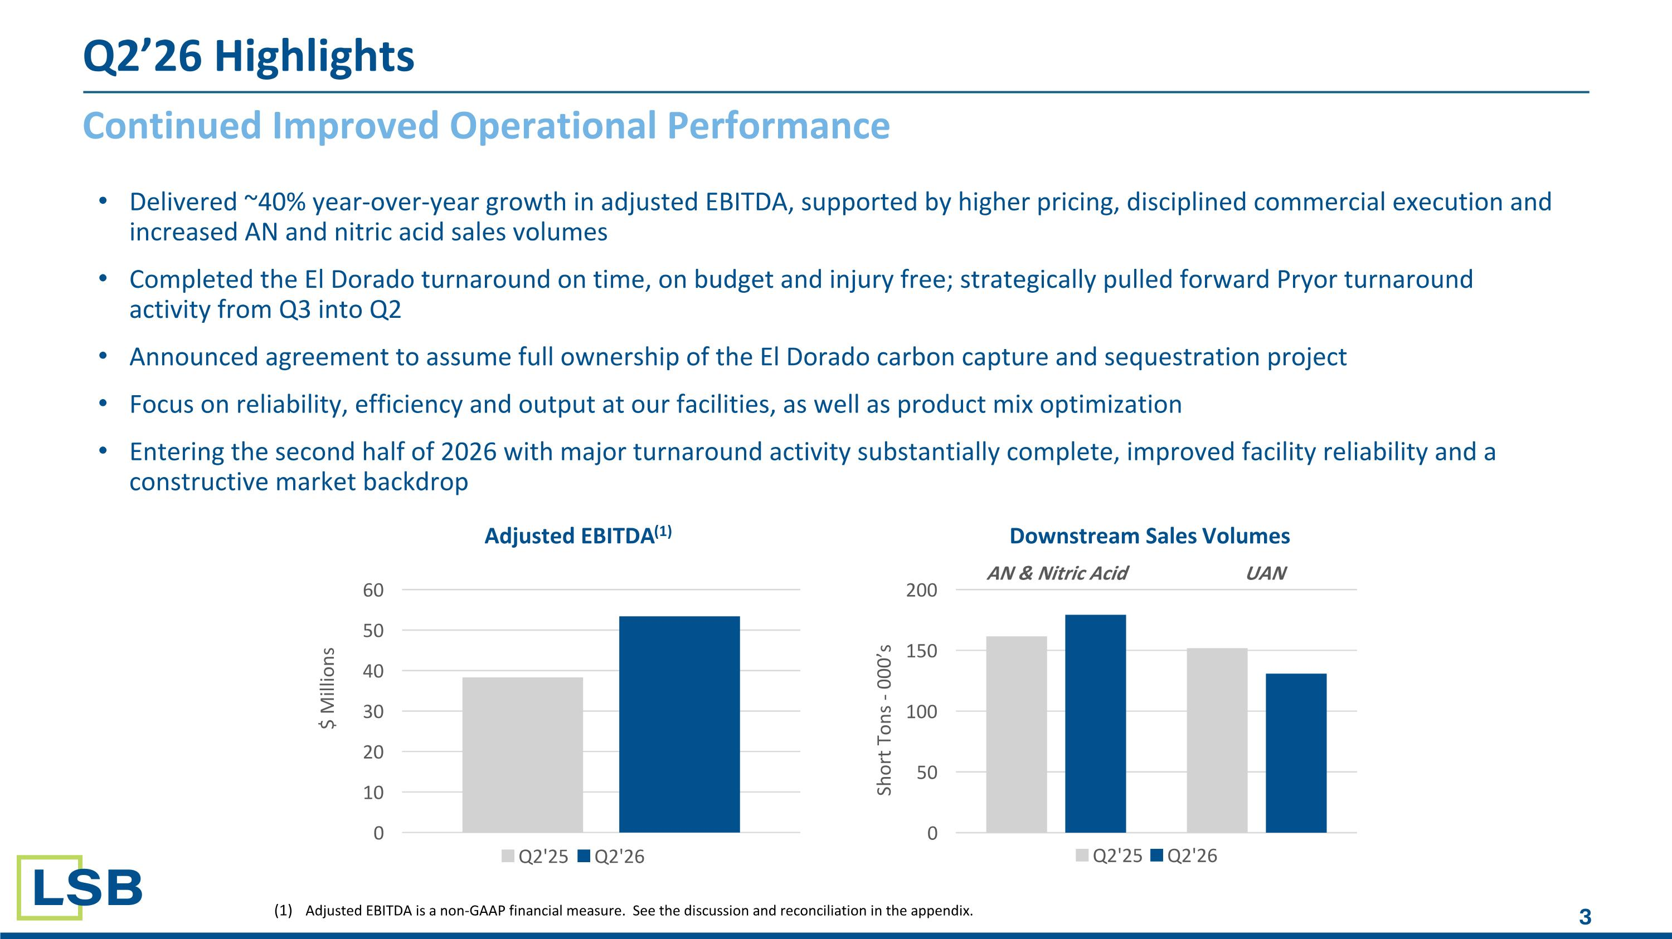
Continued Improved Operational Performance Q2’26 Highlights Delivered ~40% year-over-year growth in adjusted EBITDA, supported by higher pricing, disciplined commercial execution and increased AN and nitric acid sales volumes Completed the El Dorado turnaround on time, on budget and injury free; strategically pulled forward Pryor turnaround activity from Q3 into Q2 Announced agreement to assume full ownership of the El Dorado carbon capture and sequestration project Focus on reliability, efficiency and output at our facilities, as well as product mix optimization Entering the second half of 2026 with major turnaround activity substantially complete, improved facility reliability and a constructive market backdrop Adjusted EBITDA is a non-GAAP financial measure. See the discussion and reconciliation in the appendix​. AN & Nitric Acid UAN

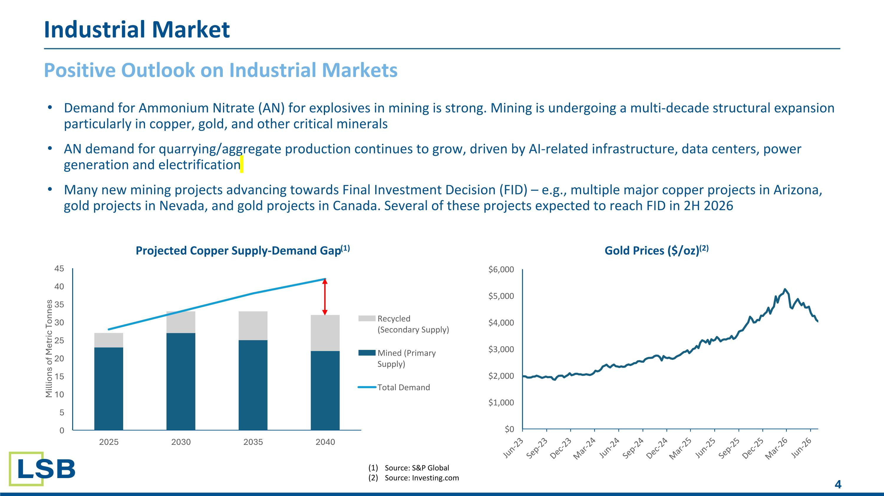
Demand for Ammonium Nitrate (AN) for explosives in mining is strong. Mining is undergoing a multi-decade structural expansion particularly in copper, gold, and other critical minerals AN demand for quarrying/aggregate production continues to grow, driven by AI-related infrastructure, data centers, power generation and electrification Many new mining projects advancing towards Final Investment Decision (FID) – e.g., multiple major copper projects in Arizona, gold projects in Nevada, and gold projects in Canada. Several of these projects expected to reach FID in 2H 2026 Positive Outlook on Industrial Markets Industrial Market Source: S&P Global Source: Investing.com

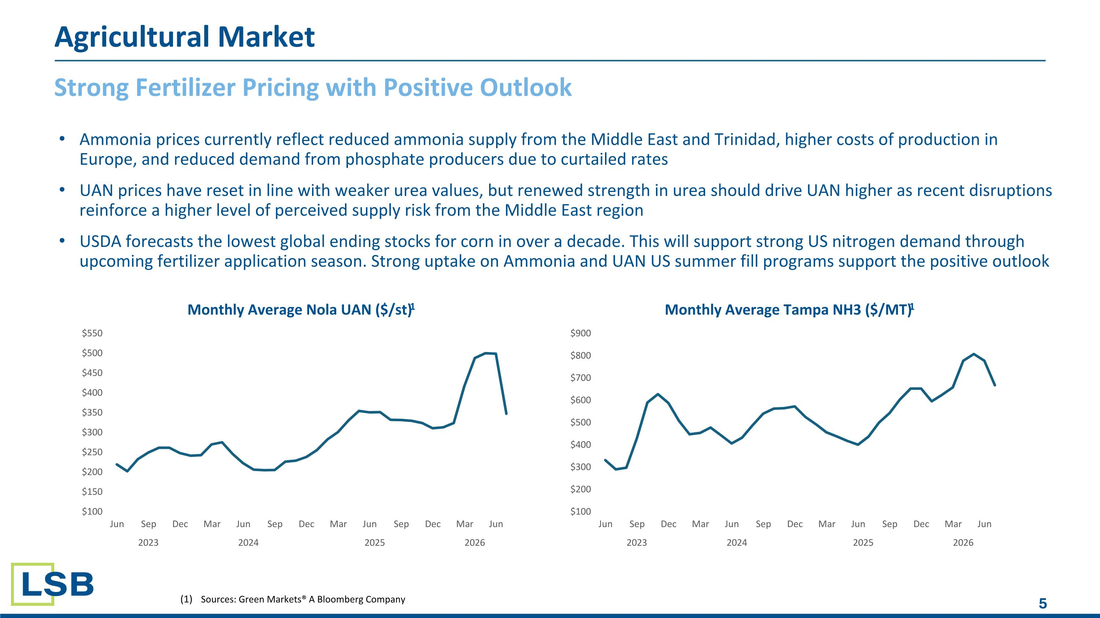
Strong Fertilizer Pricing with Positive Outlook Sources: Green Markets® A Bloomberg Company Agricultural Market Ammonia prices currently reflect reduced ammonia supply from the Middle East and Trinidad, higher costs of production in Europe, and reduced demand from phosphate producers due to curtailed rates UAN prices have reset in line with weaker urea values, but renewed strength in urea should drive UAN higher as recent disruptions reinforce a higher level of perceived supply risk from the Middle East region USDA forecasts the lowest global ending stocks for corn in over a decade. This will support strong US nitrogen demand through upcoming fertilizer application season. Strong uptake on Ammonia and UAN US summer fill programs support the positive outlook

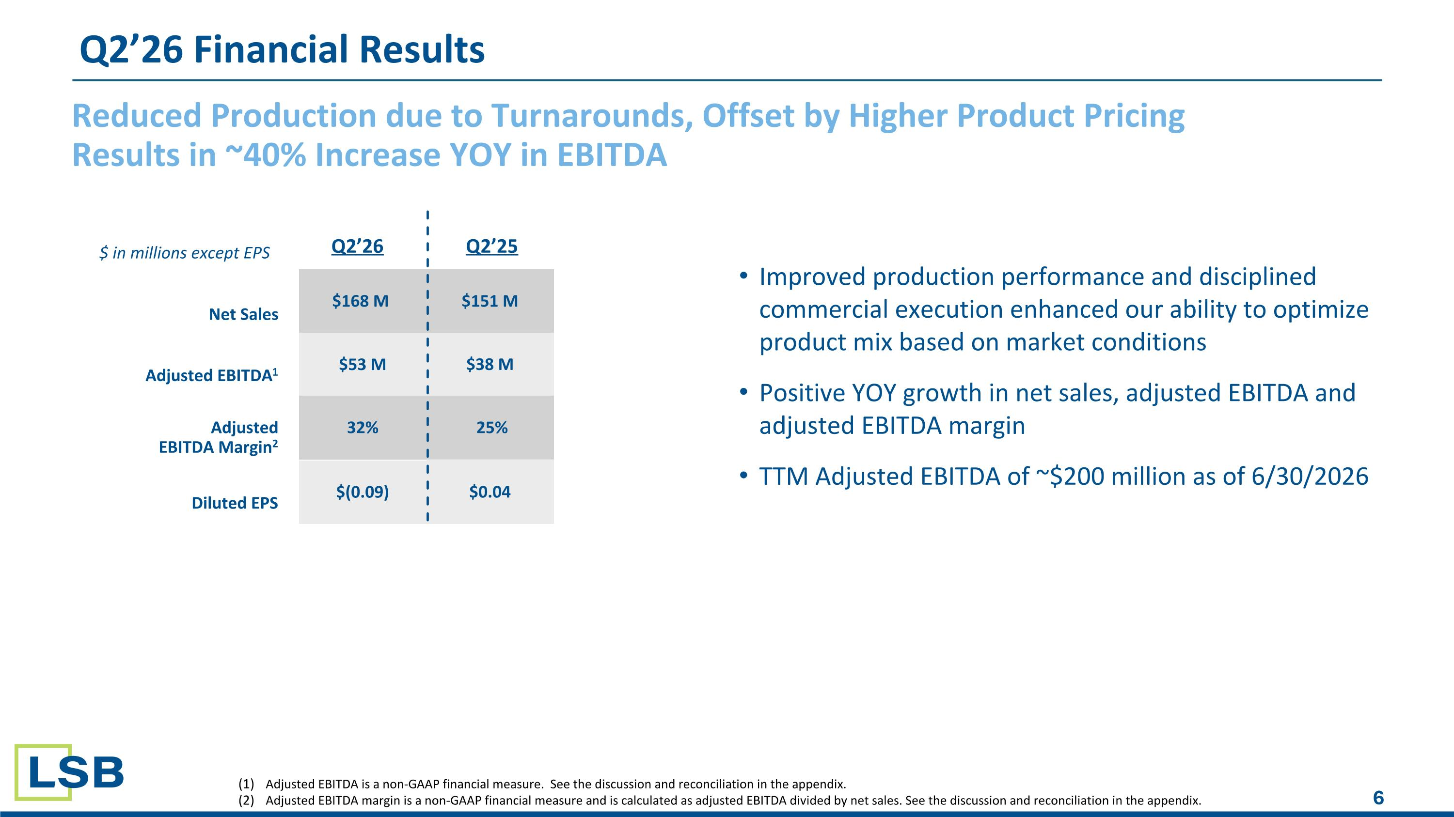
Reduced Production due to Turnarounds, Offset by Higher Product Pricing Results in ~40% Increase YOY in EBITDA Improved production performance and disciplined commercial execution enhanced our ability to optimize product mix based on market conditions Positive YOY growth in net sales, adjusted EBITDA and adjusted EBITDA margin TTM Adjusted EBITDA of ~$200 million as of 6/30/2026 Q2’26 Financial Results Adjusted EBITDA is a non-GAAP financial measure. See the discussion and reconciliation in the appendix​. Adjusted EBITDA margin is a non-GAAP financial measure and is calculated as adjusted EBITDA divided by net sales. See the discussion and reconciliation in the appendix​. Q2’26 Q2’25 $168 M $151 M $53 M $38 M 32% 25% Net Sales Adjusted EBITDA1 Adjusted EBITDA Margin2 $ in millions except EPS $(0.09) $0.04 Diluted EPS

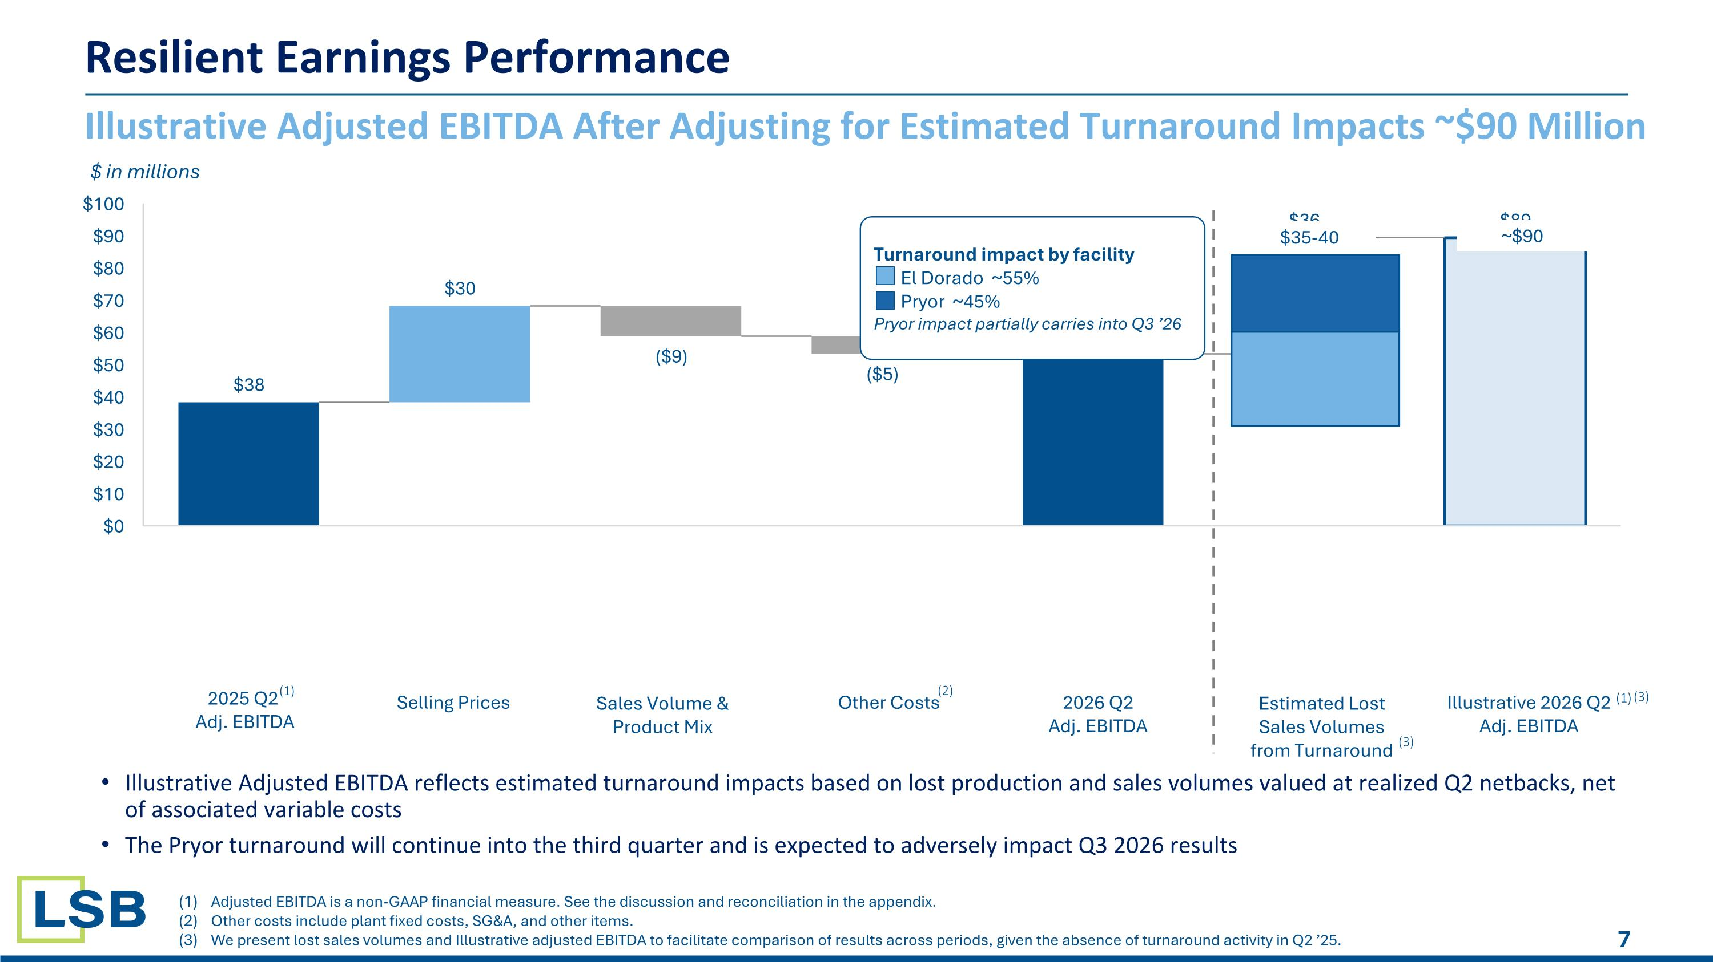
(1) (3) Resilient Earnings Performance Illustrative Adjusted EBITDA After Adjusting for Estimated Turnaround Impacts ~$90 Million $ in millions Adjusted EBITDA is a non-GAAP financial measure. See the discussion and reconciliation in the appendix. Other costs include plant fixed costs, SG&A, and other items. We present lost sales volumes and Illustrative adjusted EBITDA to facilitate comparison of results across periods, given the absence of turnaround activity in Q2 ’25. $35-40 ~$90 2025 Q2 Adj. EBITDA Selling Prices Sales Volume & Product Mix Other Costs 2026 Q2 Adj. EBITDA Estimated Lost Sales Volumes from Turnaround Illustrative 2026 Q2 Adj. EBITDA (1) (3) Illustrative Adjusted EBITDA reflects estimated turnaround impacts based on lost production and sales volumes valued at realized Q2 netbacks, net of associated variable costs The Pryor turnaround will continue into the third quarter and is expected to adversely impact Q3 2026 results (2) Turnaround impact by facility El Dorado ~55% Pryor ~45% Pryor impact partially carries into Q3 ’26

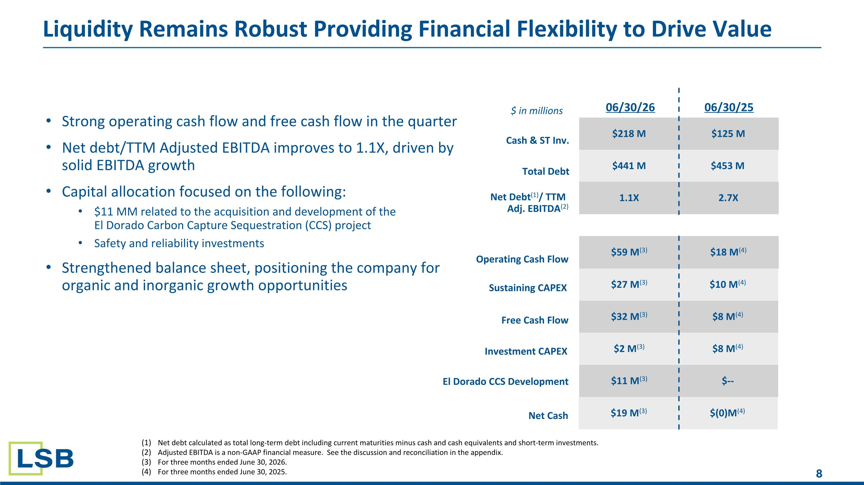
Liquidity Remains Robust Providing Financial Flexibility to Drive Value $59 M(3) $218 M $125 M $441 M $453 M $27 M(3) $10 M(4) $18 M(4) 1.1X 2.7X 06/30/26 Cash & ST Inv.​ Total Debt Sustaining CAPEX ​ Operating Cash Flow​ Net Debt(1)/ TTM ​ Adj. EBITDA(2) $ in millions $32 M(3) $8 M(4) Free Cash Flow​ 06/30/25 $2 M(3) $8 M(4) Investment CAPEX ​ $11 M(3) $-- El Dorado CCS Development Net debt calculated as total long-term debt including current maturities minus cash and cash equivalents and short-term investments. Adjusted EBITDA is a non-GAAP financial measure. See the discussion and reconciliation in the appendix​. For three months ended June 30, 2026. For three months ended June 30, 2025. Strong operating cash flow and free cash flow in the quarter Net debt/TTM Adjusted EBITDA improves to 1.1X, driven by solid EBITDA growth Capital allocation focused on the following: $11 MM related to the acquisition and development of the ?El Dorado Carbon Capture Sequestration (CCS) project Safety and reliability investments Strengthened balance sheet, positioning the company for organic and inorganic growth opportunities $19 M(3) $(0)M(4) Net Cash

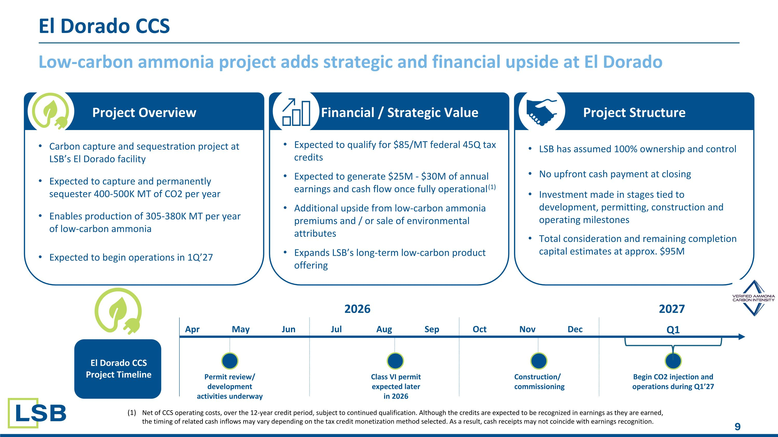
Low-carbon ammonia project adds strategic and financial upside at El Dorado El Dorado CCS Project Overview Financial / Strategic Value Project Structure Carbon capture and sequestration project at LSB’s El Dorado facility Expected to capture and permanently sequester 400-500K MT of CO2 per year Enables production of 305-380K MT per year of low-carbon ammonia Expected to begin operations in 1Q’27 Expected to qualify for $85/MT federal 45Q tax credits Expected to generate $25M - $30M of annual earnings and cash flow once fully operational(1) Additional upside from low-carbon ammonia premiums and / or sale of environmental attributes Expands LSB’s long-term low-carbon product offering LSB has assumed 100% ownership and control No upfront cash payment at closing Investment made in stages tied to development, permitting, construction and operating milestones Total consideration and remaining completion capital estimates at approx. $95M El Dorado CCS Project Timeline Net of CCS operating costs, over the 12-year credit period, subject to continued qualification. Although the credits are expected to be recognized in earnings as they are earned, the timing of related cash inflows may vary depending on the tax credit monetization method selected. As a result, cash receipts may not coincide with earnings recognition. 2026 Begin CO2 injection and operations during Q1’27 Apr May Jun Jul Aug Sep Oct Nov Dec Q1 2027 Construction/ commissioning Class VI permit expected later in 2026 Permit review/ development activities underway

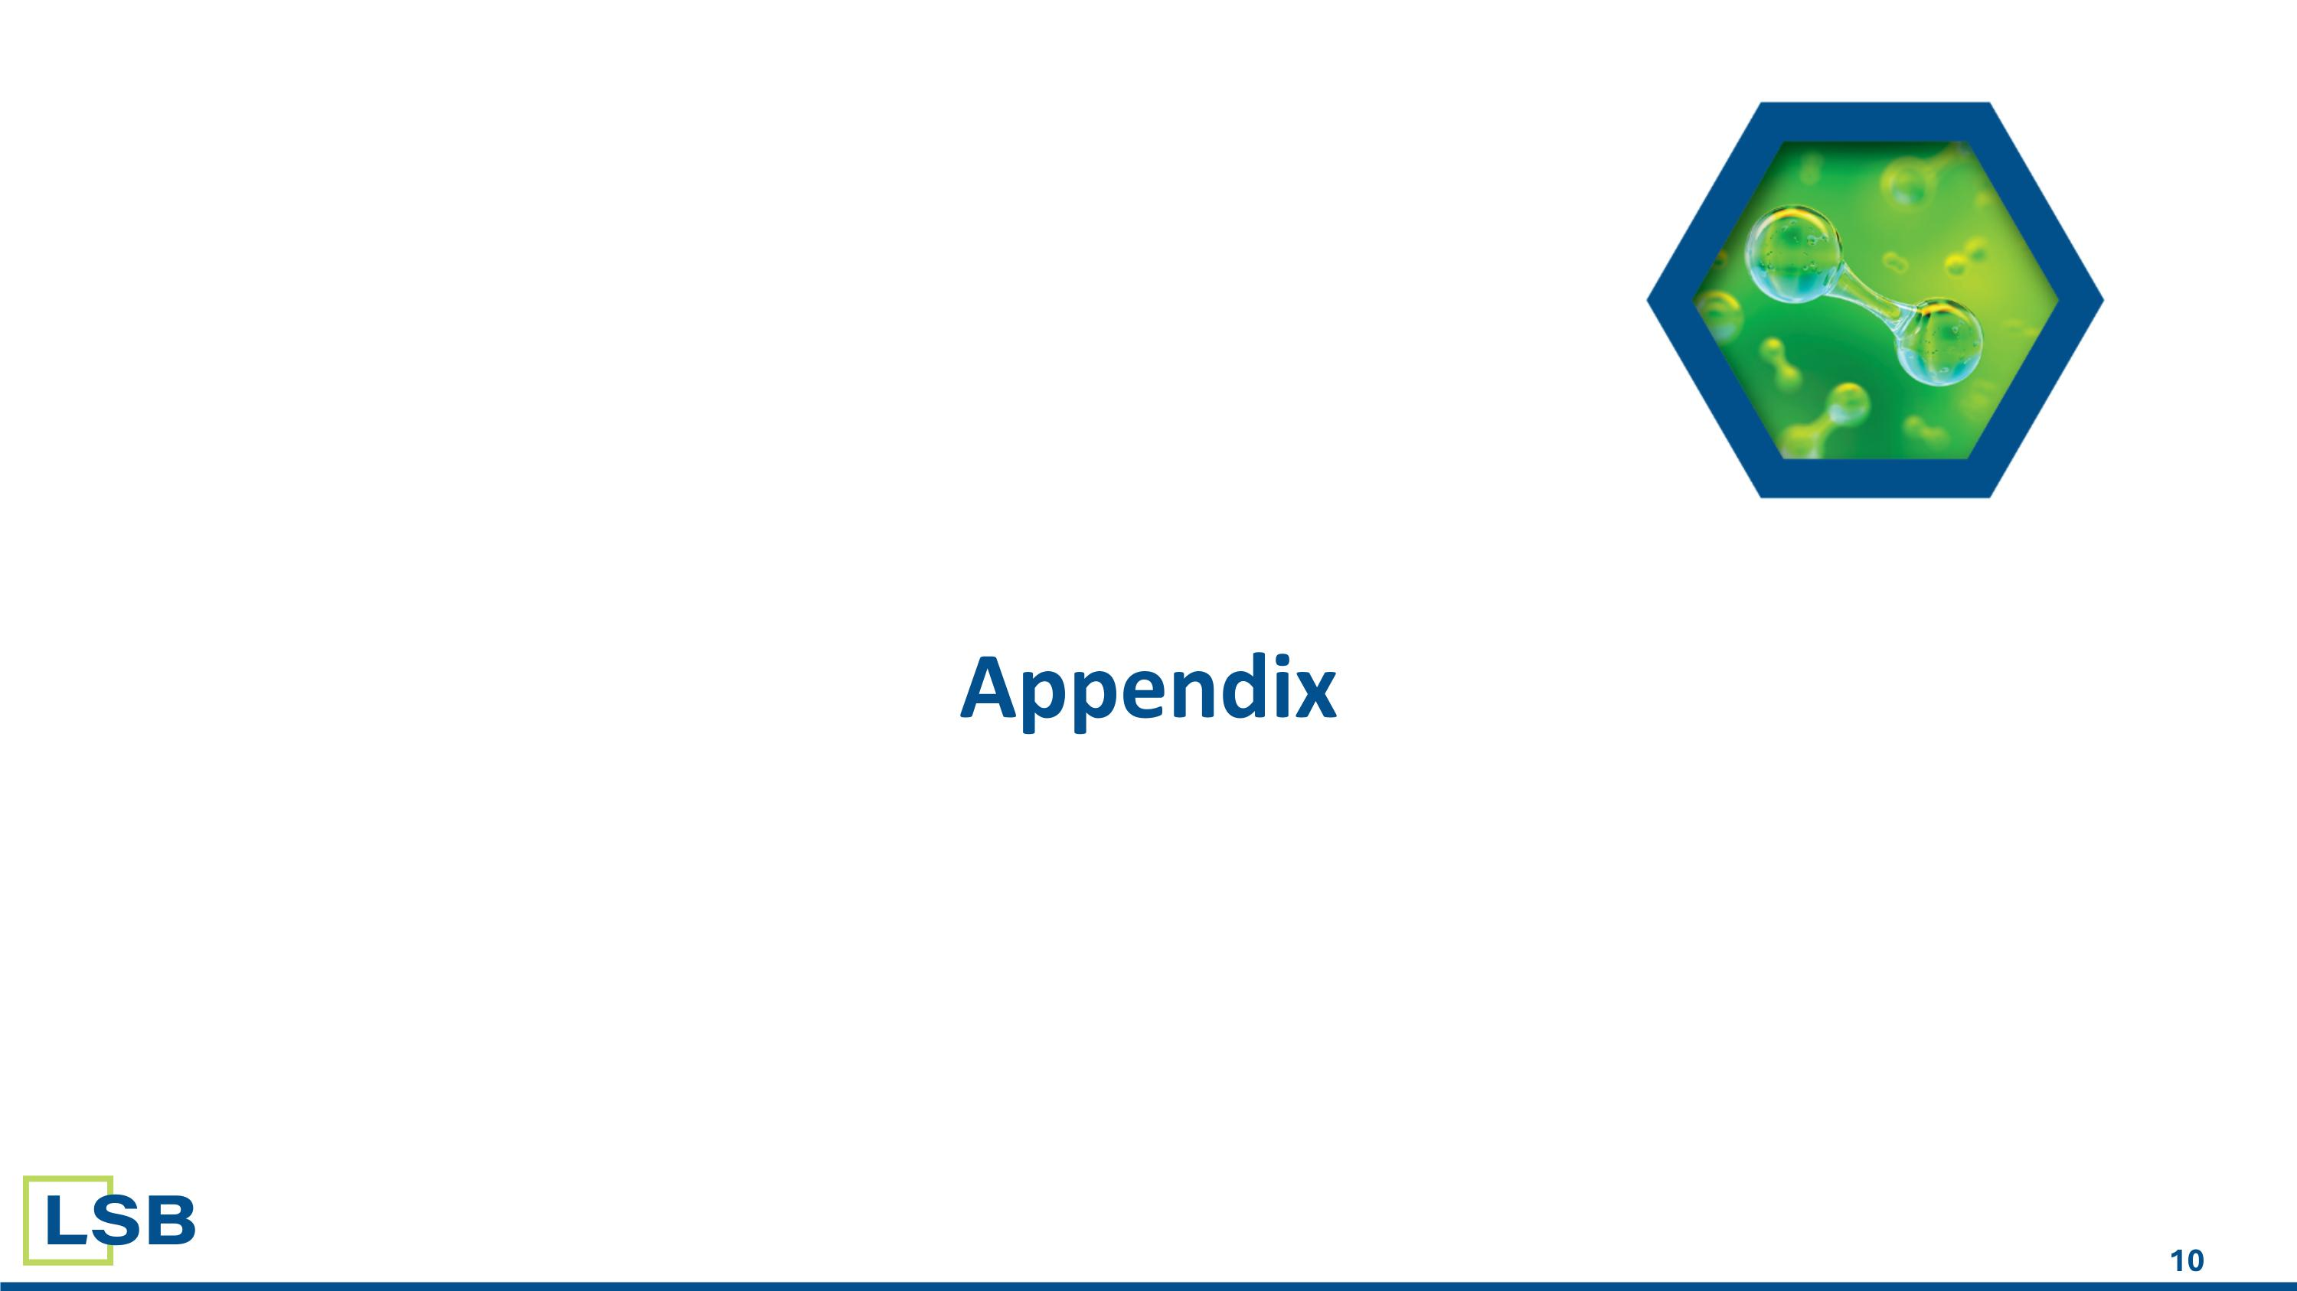
Appendix

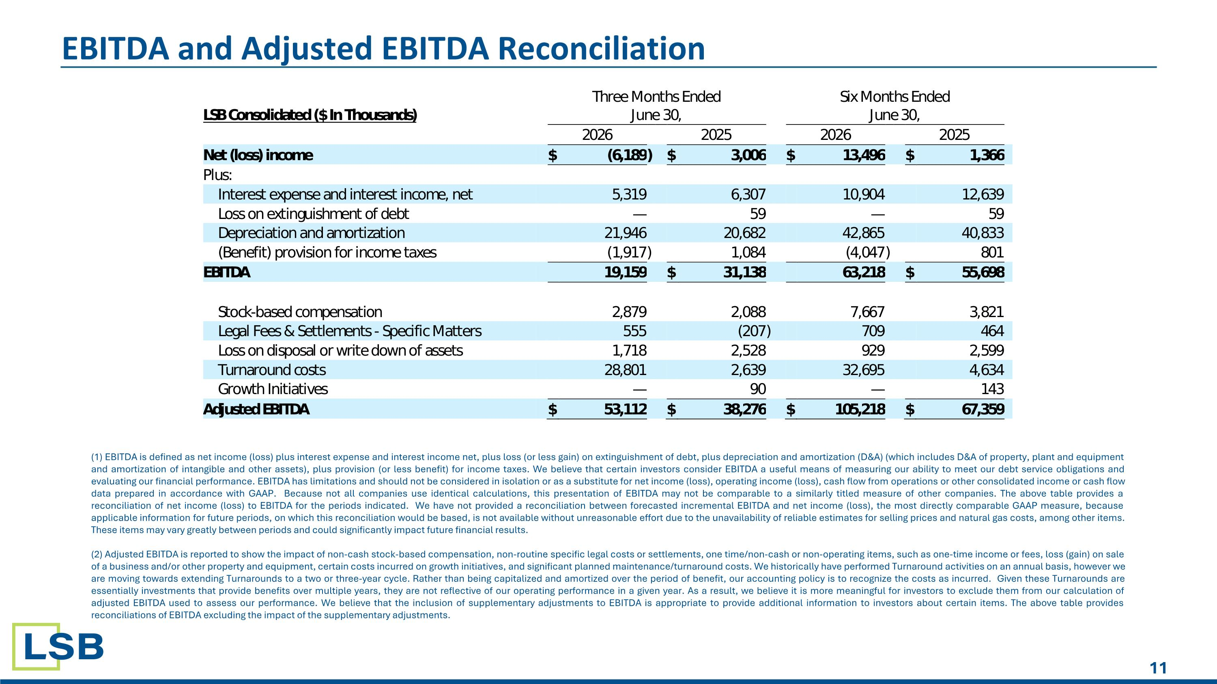
EBITDA and Adjusted EBITDA Reconciliation (1) EBITDA is defined as net income (loss) plus interest expense and interest income net, plus loss (or less gain) on extinguishment of debt, plus depreciation and amortization (D&A) (which includes D&A of property, plant and equipment and amortization of intangible and other assets), plus provision (or less benefit) for income taxes. We believe that certain investors consider EBITDA a useful means of measuring our ability to meet our debt service obligations and evaluating our financial performance. EBITDA has limitations and should not be considered in isolation or as a substitute for net income (loss), operating income (loss), cash flow from operations or other consolidated income or cash flow data prepared in accordance with GAAP. Because not all companies use identical calculations, this presentation of EBITDA may not be comparable to a similarly titled measure of other companies. The above table provides a reconciliation of net income (loss) to EBITDA for the periods indicated.​ We have not provided a reconciliation between forecasted incremental EBITDA and net income (loss), the most directly comparable GAAP measure, because applicable information for future periods, on which this reconciliation would be based, is not available without unreasonable effort due to the unavailability of reliable estimates for selling prices and natural gas costs, among other items. These items may vary greatly between periods and could significantly impact future financial results. (2) Adjusted EBITDA is reported to show the impact of non-cash stock-based compensation, non-routine specific legal costs or settlements, one time/non-cash or non-operating items, such as one-time income or fees, loss (gain) on sale of a business and/or other property and equipment, certain costs incurred on growth initiatives, and significant planned maintenance/turnaround costs. We historically have performed Turnaround activities on an annual basis, however we are moving towards extending Turnarounds to a two or three-year cycle. Rather than being capitalized and amortized over the period of benefit, our accounting policy is to recognize the costs as incurred. Given these Turnarounds are essentially investments that provide benefits over multiple years, they are not reflective of our operating performance in a given year. As a result, we believe it is more meaningful for investors to exclude them from our calculation of adjusted EBITDA used to assess our performance. We believe that the inclusion of supplementary adjustments to EBITDA is appropriate to provide additional information to investors about certain items. The above table provides reconciliations of EBITDA excluding the impact of the supplementary adjustments.

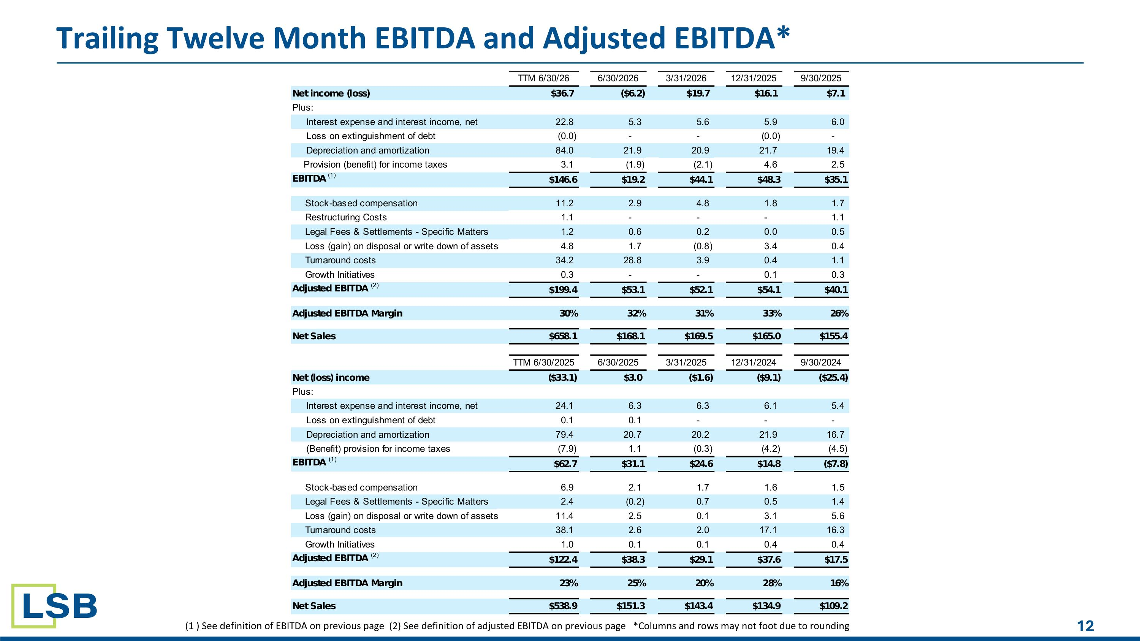
Trailing Twelve Month EBITDA and Adjusted EBITDA* (1 ) See definition of EBITDA on previous page (2) See definition of adjusted EBITDA on previous page *Columns and rows may not foot due to rounding

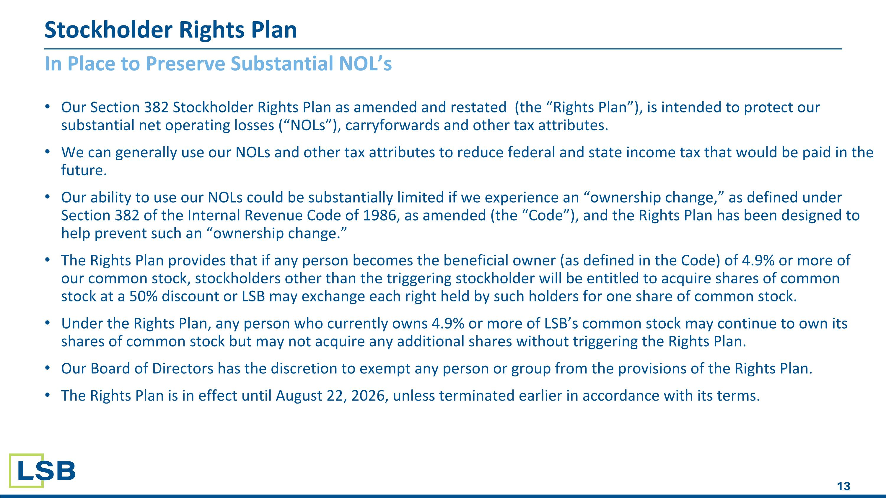
Stockholder Rights Plan Our Section 382 Stockholder Rights Plan as amended and restated (the “Rights Plan”), is intended to protect our substantial net operating losses (“NOLs”), carryforwards and other tax attributes. We can generally use our NOLs and other tax attributes to reduce federal and state income tax that would be paid in the future. Our ability to use our NOLs could be substantially limited if we experience an “ownership change,” as defined under Section 382 of the Internal Revenue Code of 1986, as amended (the “Code”), and the Rights Plan has been designed to help prevent such an “ownership change.” The Rights Plan provides that if any person becomes the beneficial owner (as defined in the Code) of 4.9% or more of our common stock, stockholders other than the triggering stockholder will be entitled to acquire shares of common stock at a 50% discount or LSB may exchange each right held by such holders for one share of common stock. Under the Rights Plan, any person who currently owns 4.9% or more of LSB’s common stock may continue to own its shares of common stock but may not acquire any additional shares without triggering the Rights Plan. Our Board of Directors has the discretion to exempt any person or group from the provisions of the Rights Plan. The Rights Plan is in effect until August 22, 2026, unless terminated earlier in accordance with its terms. In Place to Preserve Substantial NOL’s

